MSDS 6371 Project Report
Analysis of Home Sales in Ames, Iowa

Richard M. Palmer
Jonathan Tan
Anthony Yeung

Analysis 1

Background
The goal of this first analysis was to determine the relationship between the sale price of a house and its square footage. Additional consideration was also given to the neighborhood each house was located in. There were a total of 381 observations within the three neighborhoods of NAmes, Edwards, and BrkSide.

Checking Assumptions
- There is no evidence against a linear relationship between the sale prices and area (appendix diagram 1)
- Multivariate normality is satisfied by the plot of residuals (appendix diagram 2)
- Independent data must be assumed in order to proceed
- Covariance also appears fairly linear (appendix diagram 3)

Model
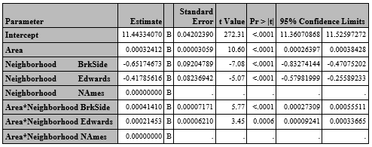
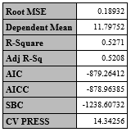

LogSalePrice vs GrLivArea + Neighborhood
Several houses had unusually large areas, and were removed as outliers
Adj. R² = 0.5271

Y is the final sale price of the house
𝛽0 is the y-intercept, or the theoretical value of a house with an area of zero square feet located in the NAmes neighborhood
𝛽1 is square footage of the house
𝛽2 is the coefficient representing the modifier to sale price if the house is located in BrkSide
𝛽3 is the coefficient representing the modifier to sale price if the house is located in Edwards
𝛽4 is the coefficient representing how the area of the house affects the sale price if the house is located in BrkSide
𝛽5 is the coefficient representing how the area of the house affects the sale price if the house is located in Edwards

Model Metrics
The independent variable, the area of the house, has been log transformed to meet normality assumptions of linear regression. The coefficients of the regression equation show that the average sale price of houses in BrkSide and Edwards are less affected by the square footage of the house than in NAmes and are lower on average as well.
Confidence intervals
Intercept - We can be 95% certain that the true mean of the intercept will fall between 11.443079 +/- 0.039466*289.94 = (-0.3488, 23.247)
𝛽2 - We can be 95% certain that the true value of the logged area multiplier for BrkSide will fall between -0.577635 +/- 0.07762*-4.97 = (-0.1918, -0.9634)
𝛽3 - We can be 95% certain that the true value of the logged area multiplier for Edwards will fall between -0.385474 +/-0.077622 *-4.97 = (-0.0003, -0.7712)
We can interpret this as every 1 sq ft increase in the area of the house will increase the sale price by 0.003%. This can also be interpreted as every additional 100 sq ft of living space increases the price of the house an average of 0.3%

Conclusion
Generally positive correlation across all neighborhoods, NAmes has the higher prices/higher correlation, followed by Edwards, then BrkSide) Given the data provided, the sale price of a house in the three neighborhoods covered by this analysis positively correlates to the living area/square footage of the house. From the confidence intervals we can conclude that square footage a house has the strongest effect in the NAmes neighborhood, and the weakest effect in BrkSide.

Analysis 2

Background
The second item of analysis to build a predictive model for the sale prices of homes in the three neighborhoods NAmes, BrkSide, and Edwards based on several attributes of the houses in the provided dataset.

Checking Assumptions
- There was no evidence against the normality of sales prices with relation to the primary variables of the model (appendix diagram 5)
- Residual plot shows slight left skew, with some high outliers. This was addressed with a log transformation of the sale price and omission of some extremely high priced houses (appendix diagram 5)
- There was no evidence against a linear relationship between the sales price and primary variables (appendix diagram 5)
- Independence of data must be assumed to proceed

Model
The sale price of the houses was log transformed for all models.

Model Metrics
Forwards selection – Adj. R² = 0.9121
Backwards elimination - Adj. R² = 0.9280
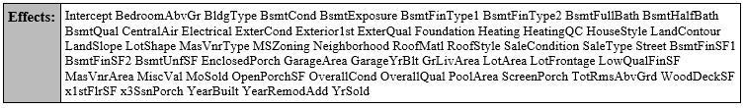
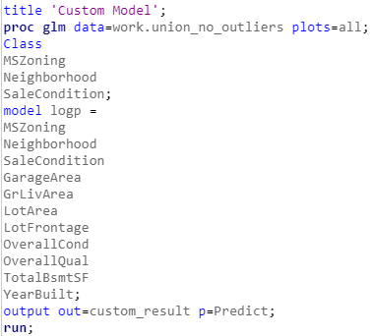
Stepwise – Adj. R² = 0.9133
Custom Model - Adj. R² = 0.9096
Effects ------------------------->

Predictive Models | Adjusted R² | CV PRESS | Kaggle Score
Forward | 0.9221 | 22.64 | 0.12386
Backward | 0.9280 | 23.31 | 0.12435
Stepwise | 0.9133 | 21.07 | 0.12973
CUSTOM | 0.9096 | 20.69 | 0.13746

Conclusion
The analysis supports the assumption that, all other factors being approximately equal, average sale prices tend to be highest in NAmes and lowest in BrkSide. Some highly influential variables in the final sale price of houses in all three neighborhoods that were determined by evaluation of adjusted R² are SaleCondition and LotArea.
Judging by the Adjusted R² and Kaggle Score, the backward elimination predictive model appears to yield the best results predicting the sale values of the testing set. Further refining the models may change this, as the Kaggle Score and R² values of this one model are only marginally better than the others.

